**Worksheet 2.4 or 7**

**Student Name:** Vivek Kumar **UID:** 21BCS8129

**Branch:** BE-CSE (LEET) **Section/Group:** ON20BCS-809/A

**Semester:** 4th Sem **Date of Performance:** 01/04/2022

**Subject Name:** MPI Lab **Subject Code:** 22E-20CSP-253

**1. Aim/Overview of the practical:**

1. Shift Left 16-bit number by 1bity.
2. Shift Left 16-bit number by 2bit.

**2. Task to be done:**

Write an 8085 Microprocessor program to shift left of 16-bit number by 1bt and 2bit.

**3. Apparatus/Simulator used (For applied/experimental sciences/materials-based labs):**

1. 8085 Jubin simulator version 2 (Microprocessor Simulator)
2. Java (jdk/ jre1.8.0_321)

**4. Algorithm/Flowchart (For programming-based labs):**

**Algorithm to find left shift of 16-bit number by 1bit:**

1. Load the data to the HL pair from 2000, 2001 memory address.
2. Add the HL pair with the same to find the 1bit Left shift using DAD.
3. Store the 1bit left shifted value from HL pair to 2002,2003 memory location.
4. End the execution using HLT.

**Algorithm to find left shift of 8-bit number by 2bit:**

1. Load the data to the HL pair from 2000, 2001 memory address.
2. Add the HL pair with the same to find the 1bit Left shift using DAD.
3. Add the HL pair with the same to find the 2bit Left shift using DAD
4. Store the 1bit left shifted value from HL pair to 2002,2003 memory location.
5. End the execution using HLT.

**5. Description/ Code:**

**Program to find the left shift of 16-bit number by 1bit:**

# ORG 1000H

LHLD 2000

DAD H

SHLD 2002

HLT

# ORG 2000H

# DB 96H,75H

**Program to find the left shift of 16-bit number by 2bit:**

# ORG 1000H

LHLD 2000

DAD H

DAD H

SHLD 2002

HLT

# ORG 2000H

#DB 96H,75H

**6. Result/Output/Writing Summary:**

**Program to find the left shift of 16-bit number by 1bit:**

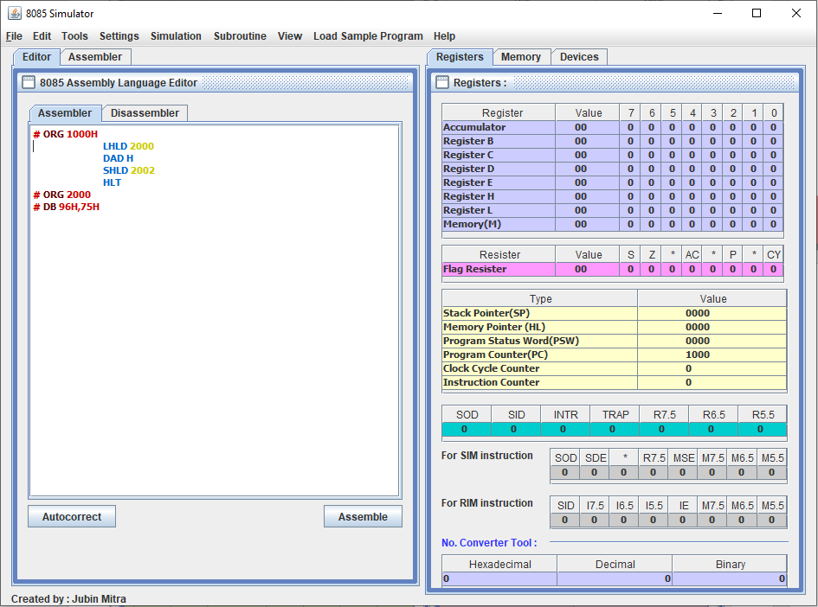

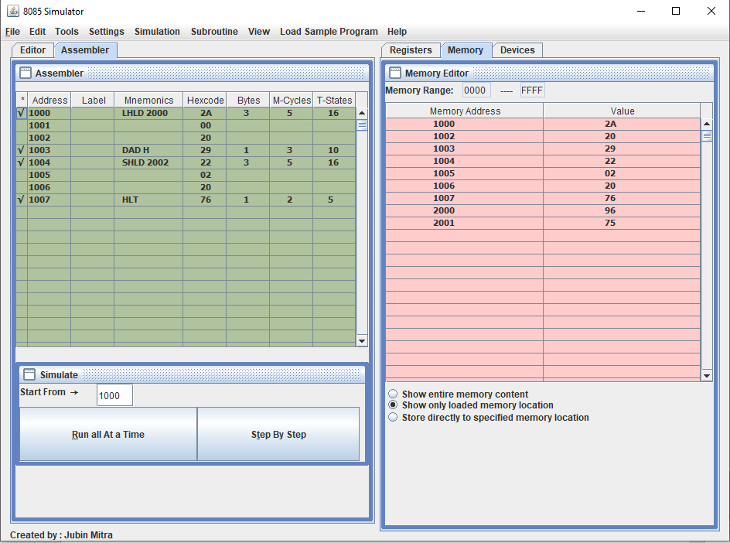

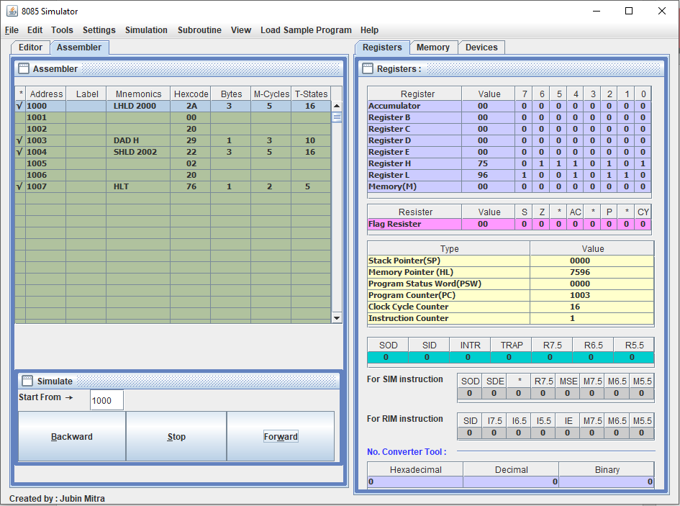

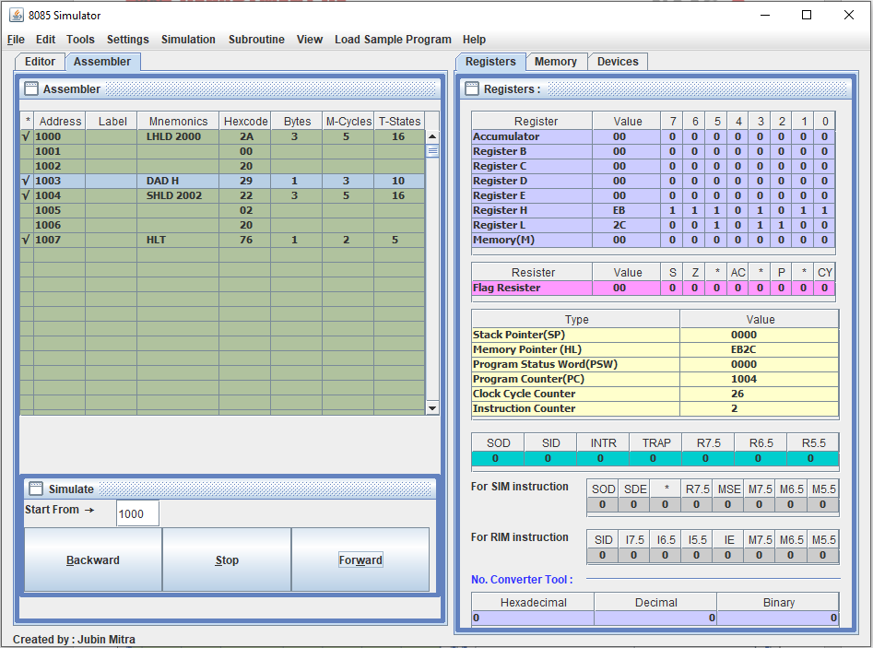

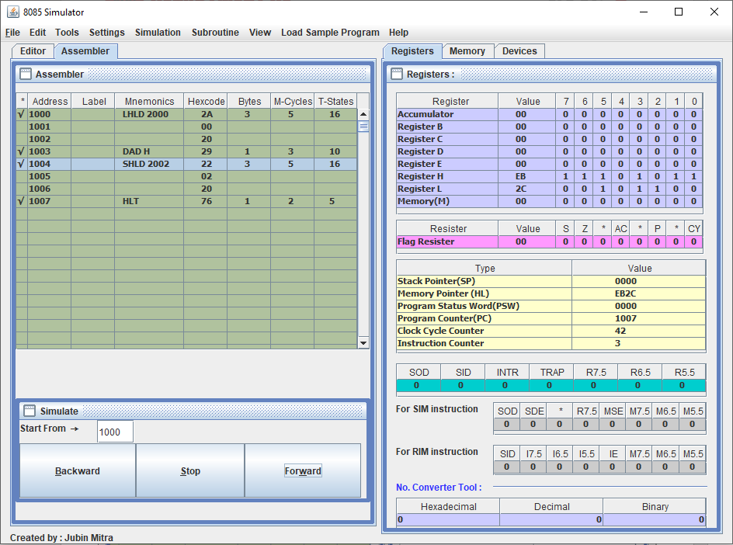

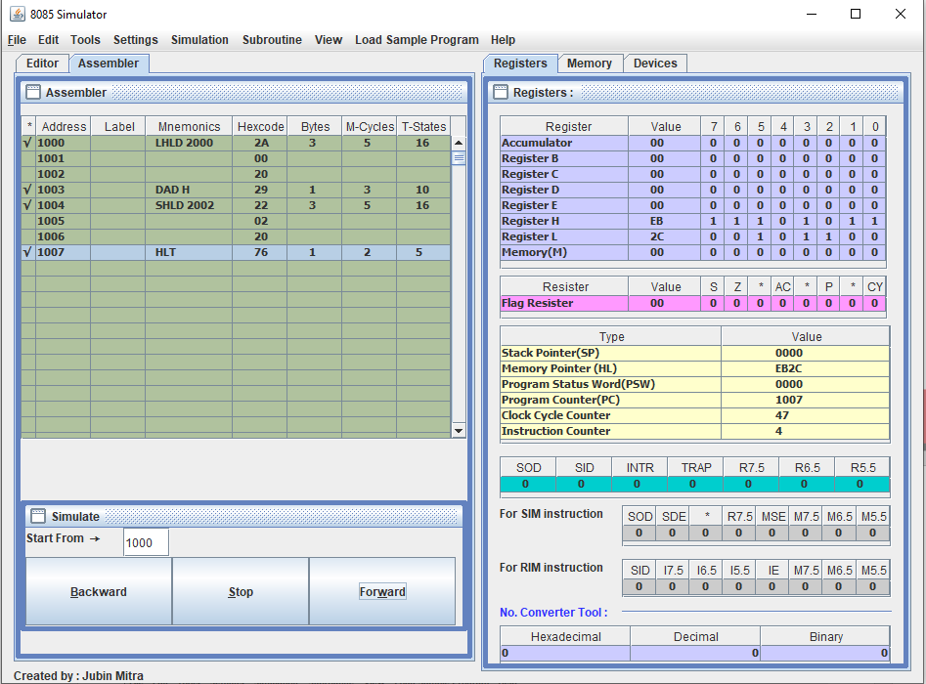

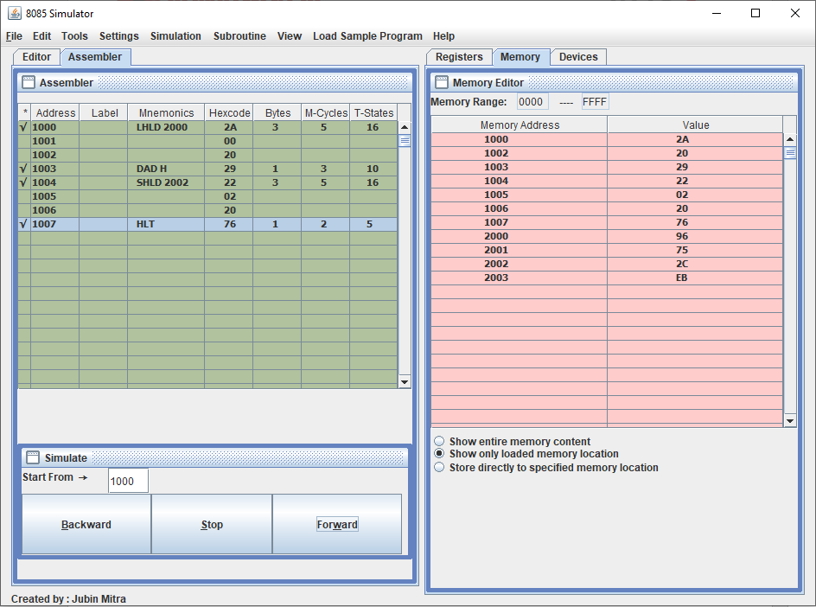

**Program to find the left shift of 16-bit number by 2bit:**

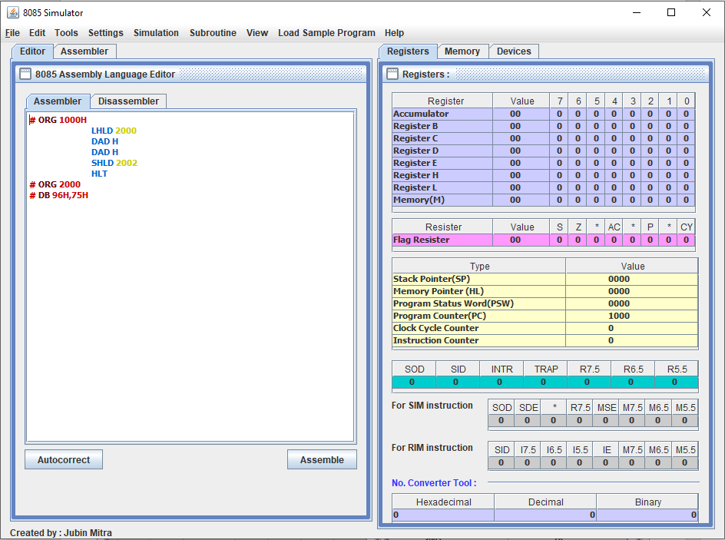

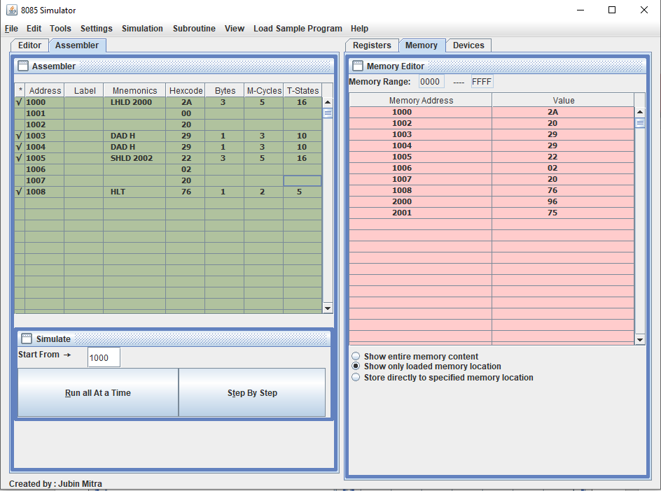

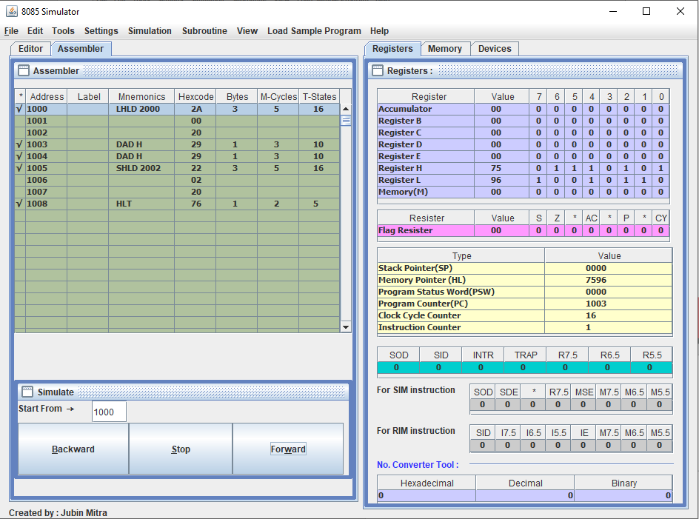

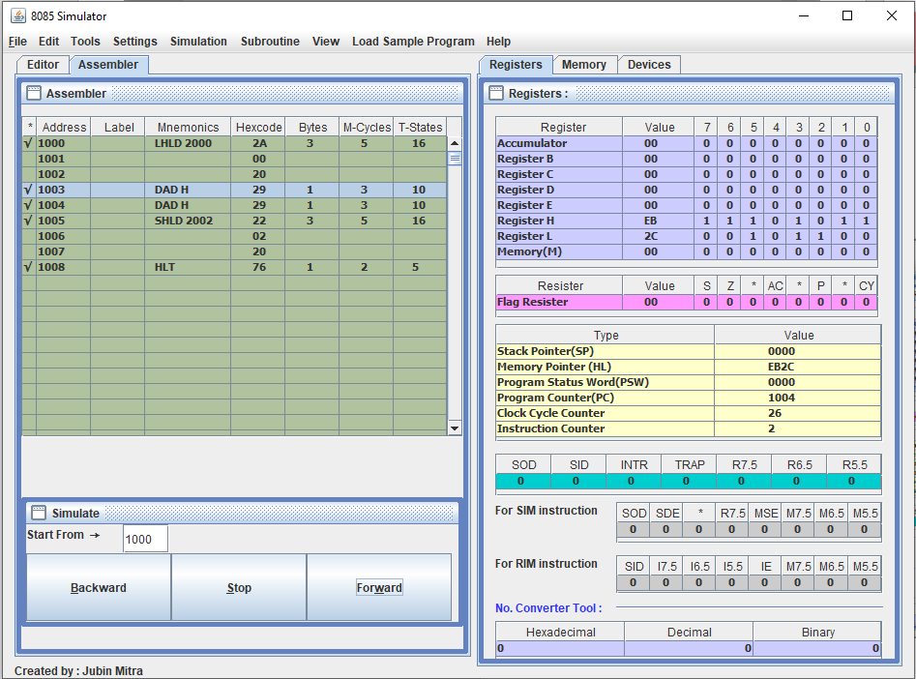

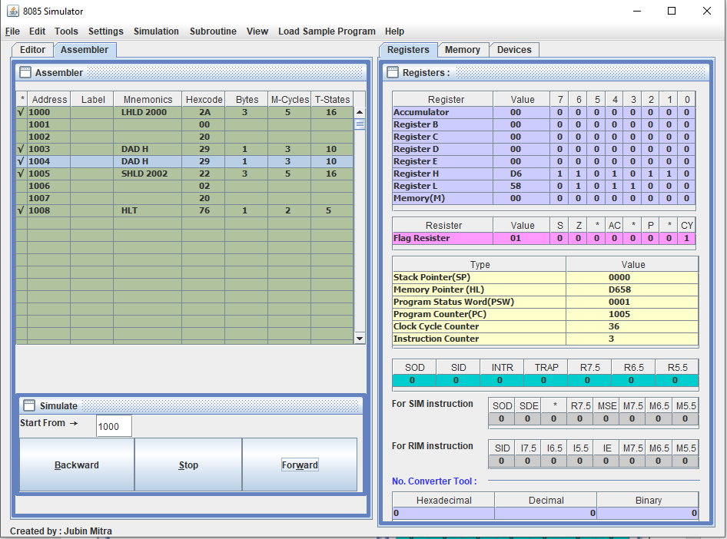

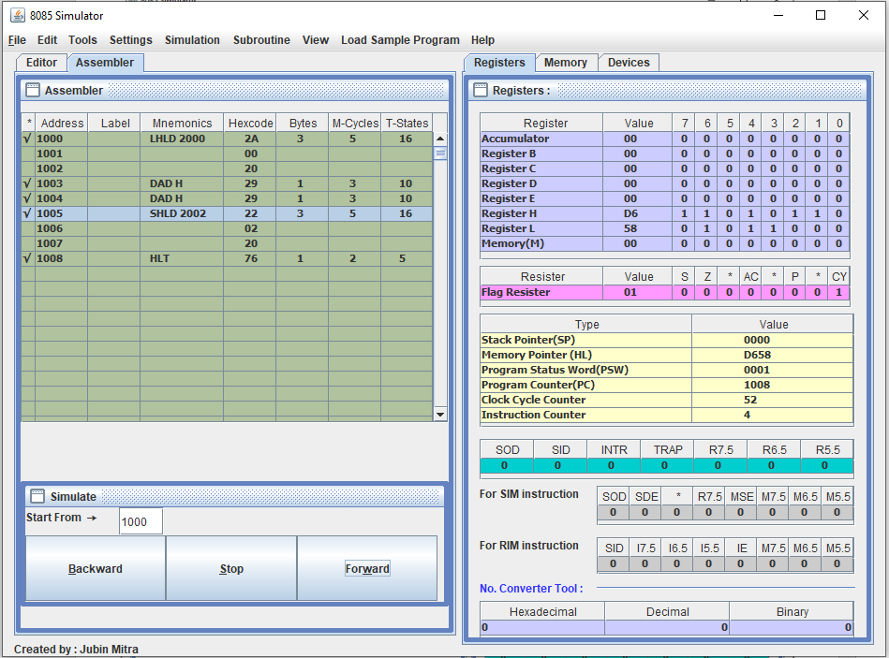

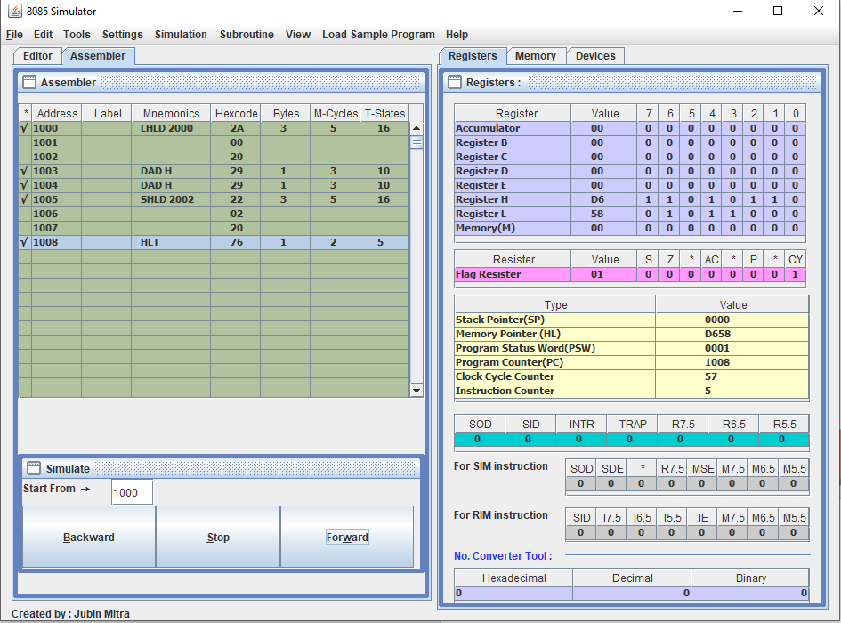

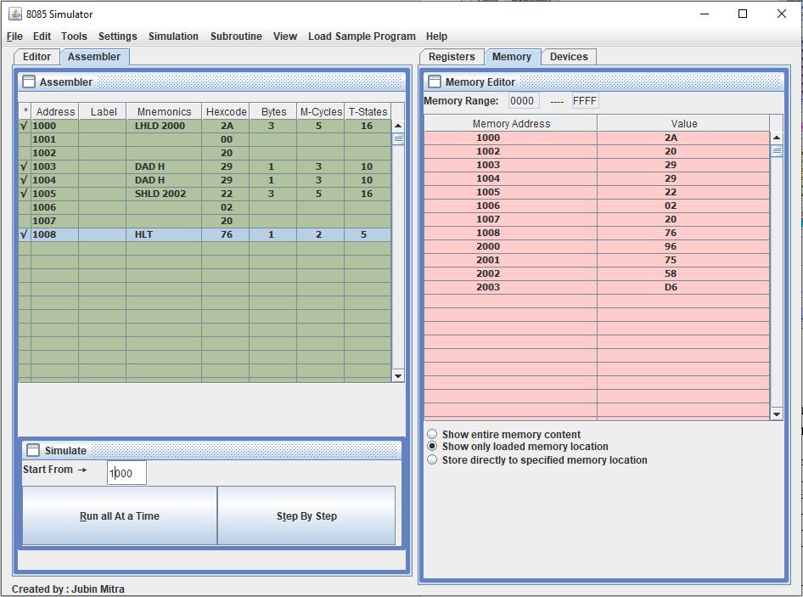

**Learning outcomes (What I have learnt):**

1. Learnt to find the 1bit left shift of 16-bit number.
2. Learnt to find the 2bit left shift of 16-bit number.

**Evaluation Grid (To be created as per the SOP and Assessment guidelines by the faculty):**

|  |  |  |  |
| --- | --- | --- | --- |
| Sr. No. | Parameters | Marks Obtained | Maximum Marks |
| 1. |  |  |  |
| 2. |  |  |  |
| 3. |  |  |  |
|  |  |  |  |